Steps to add VBA macro

1. Import the frmTimelines.frm and modCallUserForms.bas file in the **ProjectGlobal(Global.MPT)** project.  
   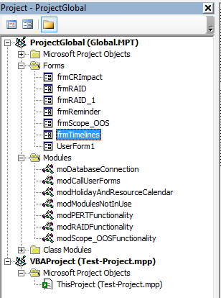
2. To easily access the functions of this macro, I’ve added an icon on the Quick Access Toolbar of MS Project.  
   
3. Below is how to add this macros to the top bar;  
   Click on the down arrow visible on the top bar, and then click on More Commands.  
   
4. You should see the Project Options dialog. Refer below snippet. Here select “Quick Access Toolbar” in the left section and then choose “Macros” from the “Choose commands from” drop down. The list of Public macros will be shown. Add the “Call_AddToTimeline” Macros which I’ve shown in point # 2 above. Once done click on OK and you should be able to see the icons in the Quick Access Toolbar.  
    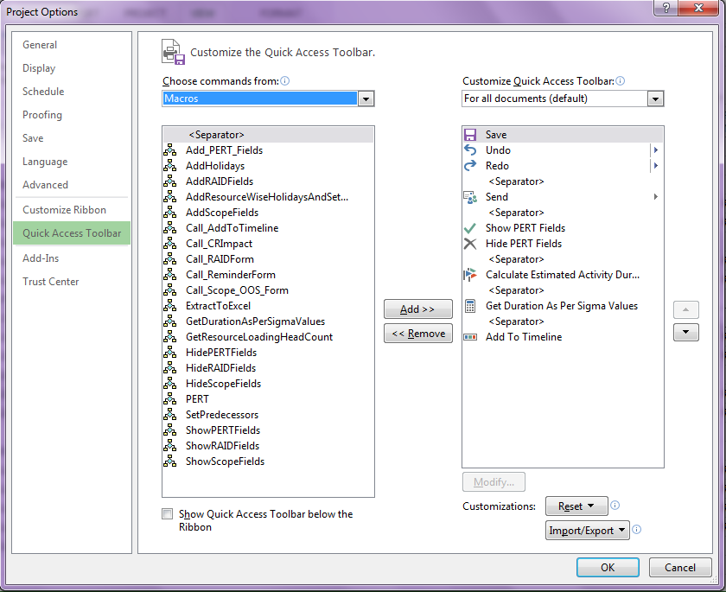
5. Post this when you click the “Add to Timeline” button in the Quick Access Toolbar, a dialog box will be shown which will ask you to select the start and end dates. All the milestones between these two dates will be added to the Timeline, after clicking the OK button. It also shows a checkbox which when selected, removes the previously added items from the timeline.   
     
   **Please note:** This macro adds and removes the tasks from the default Timeline only.  
   